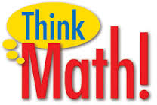
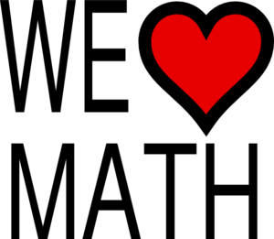
REMINDER:
PLEASE JOIN US
for

@ Patricia St Clair Elementary
Monday, December 7th from 5 to 7
Visit the Elementary Gym for:
- Hands-On Math Games
- Make & Take Activities
The Elementary Cafeteria will have:
- Food
- Refreshments

During the school day, students will also have the opportunity to attend an Arithmetickles Math Assembly in the MS/HS cafeteria at the following times: K-2nd: 1:00 PM / 3rd-6th: 2:00 PM. Arithmetickles is an interactive game show assembly that combines math and fun! The program is produced by the Children’s Theatre Center of New Jersey and is presented throughout the United States. Thanks to the Robert Gustine Grant for funding the above opportunities for our students.
